**Ex 23-1 # 1:**

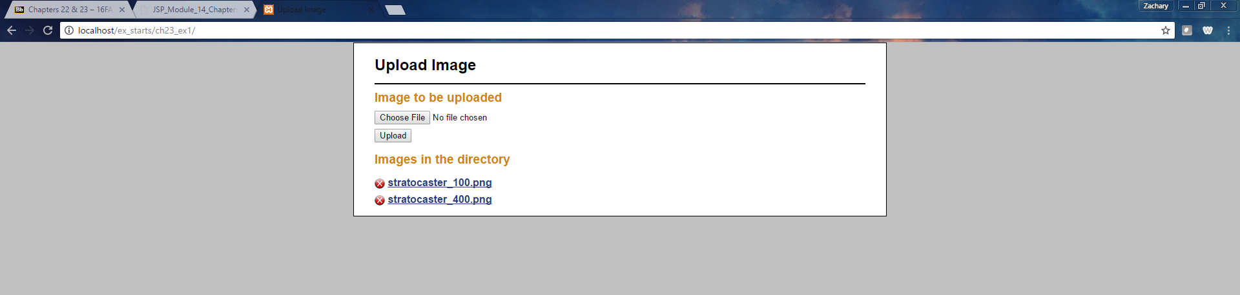

Able to run the application in the directory.

**Ex 23-1 #2:**

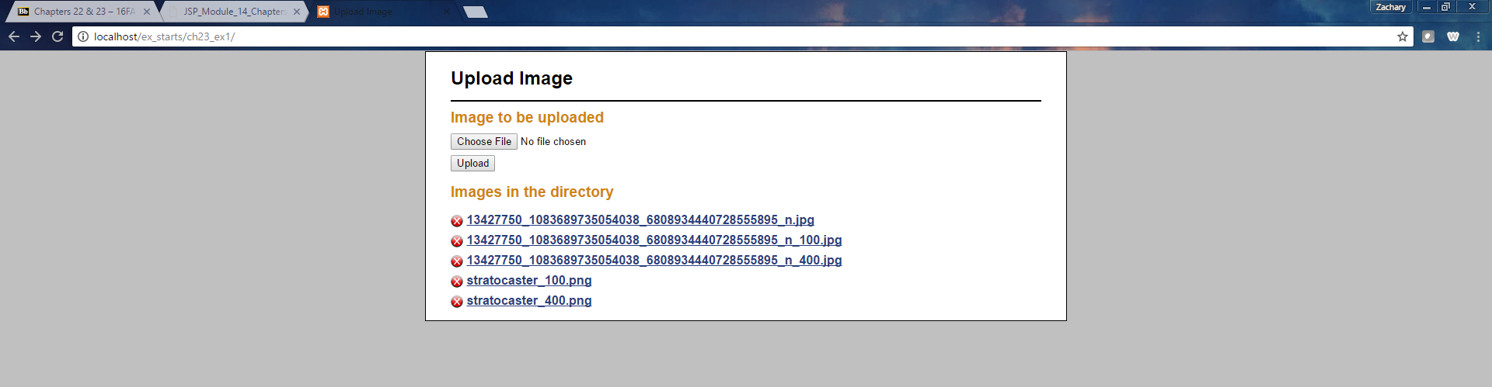

Abler to upload images, noticed it creates three instances of this image with different sizes.

**Ex 23-1 #3:**

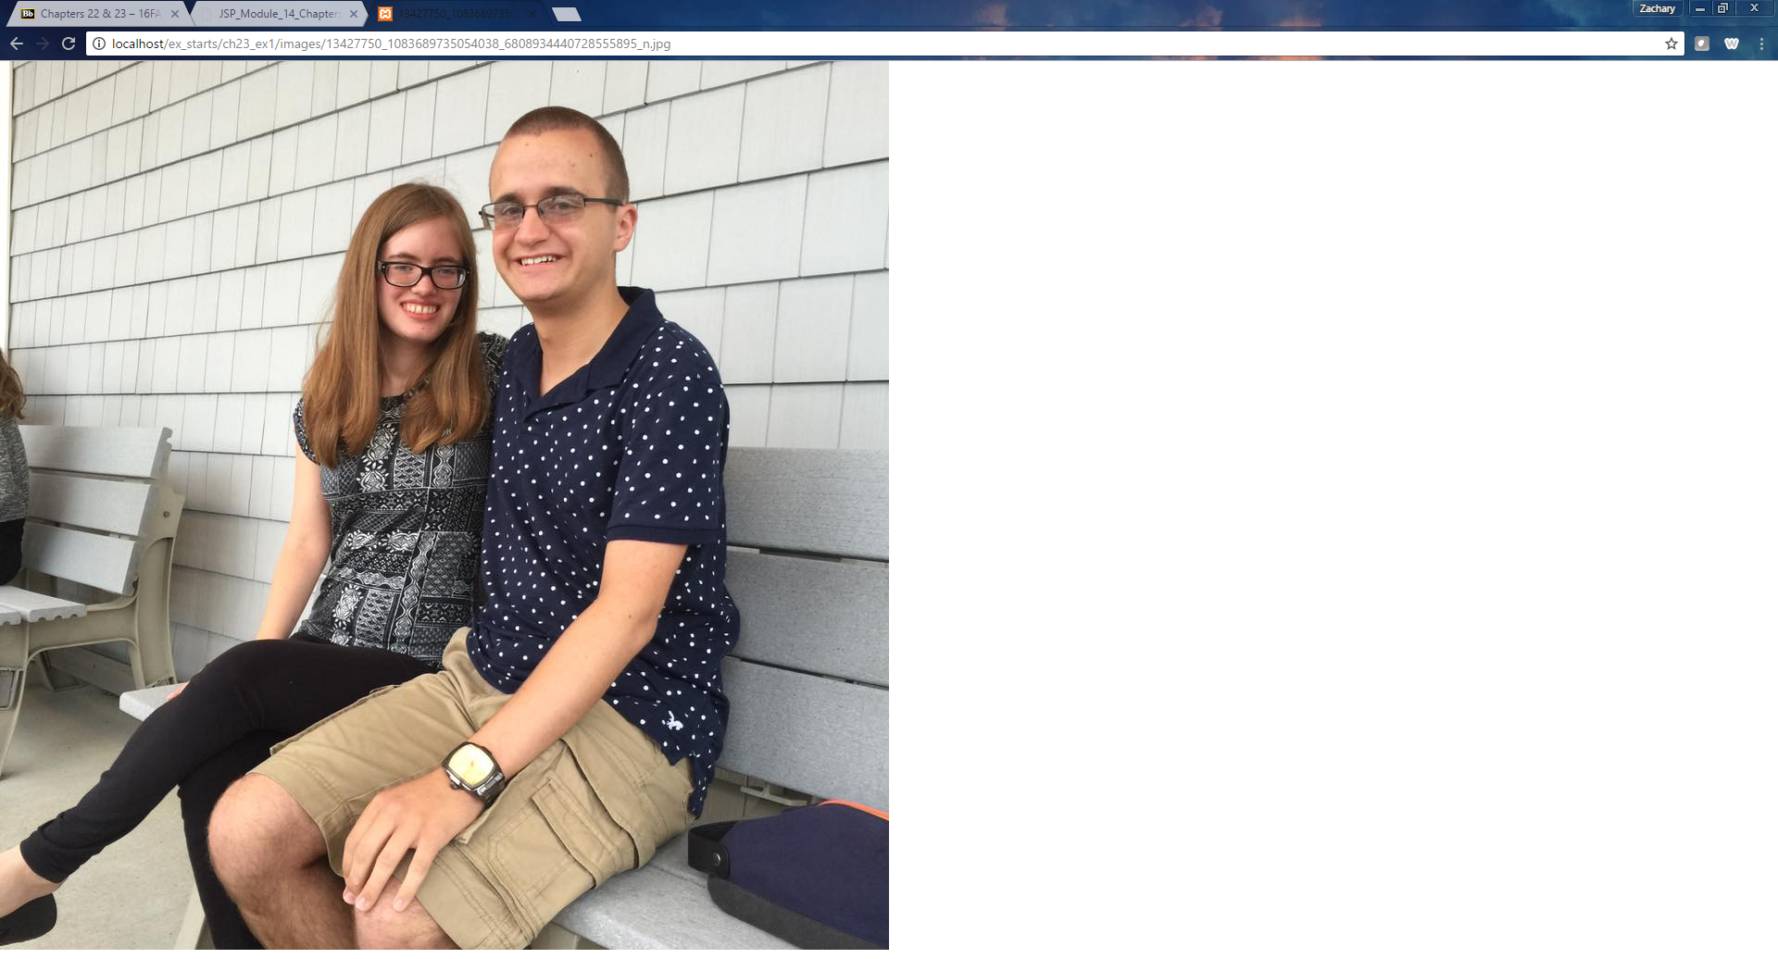

Able to view the images successfully (that’s me and my girlfriend ☺)

**Ex 23-1 #4:**

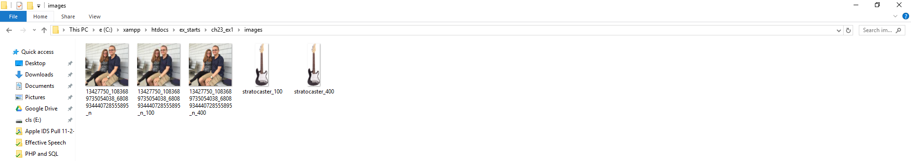

The images are within the directory as they should be.

**Ex 23-1 #5:**

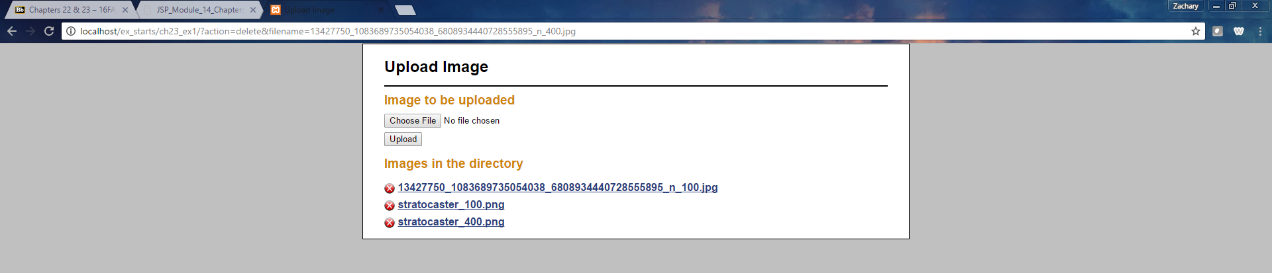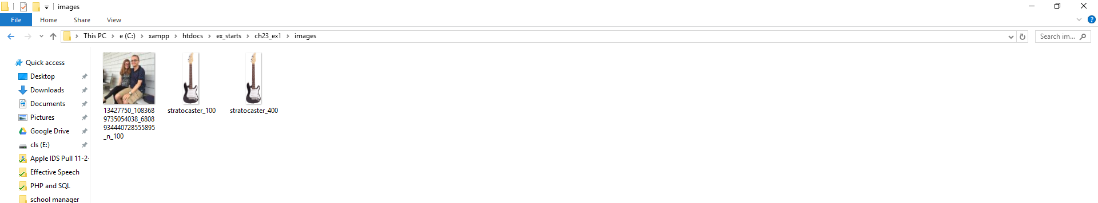

Able to successfully delete two of the images I uploaded from the directory using the application and it is reflected as it should be.

**Ex 23-1 #6:**

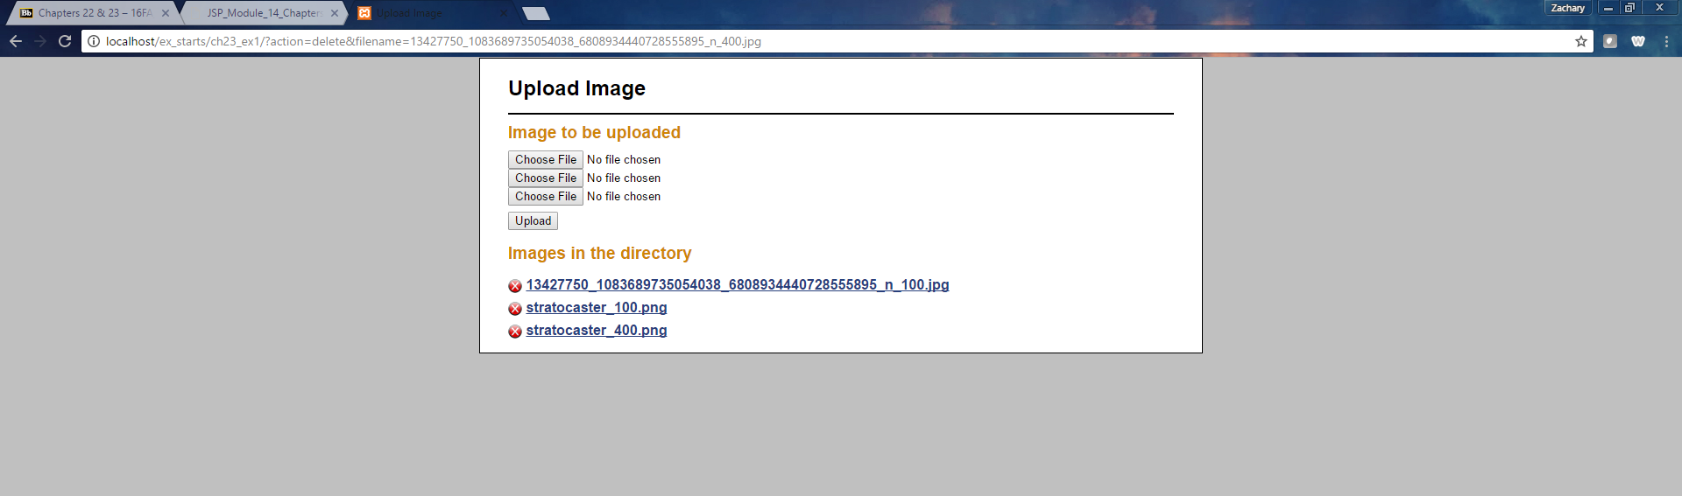

Now have three Choose File buttons so the user can do three files at a time.

**Ex 23-1 #7:**

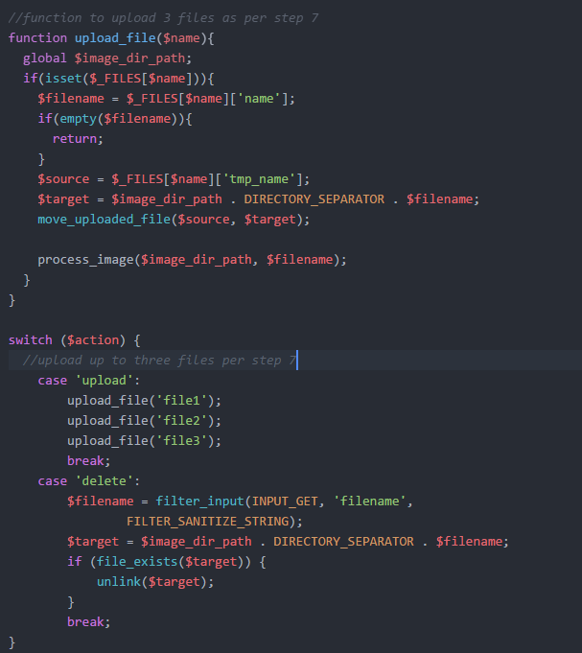

Changes made to upload three files (img) at once.

**Ex 23-1 # 8:**

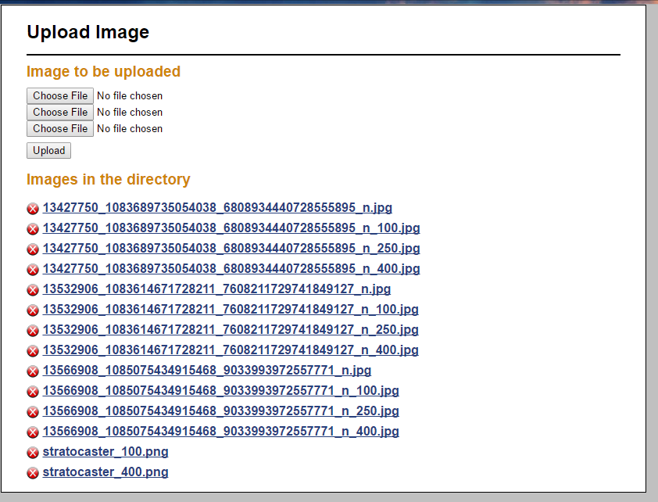Uploads 3 of each successfully.